

CAPSTONE PROJECT REPORT
Report 1 – Project Introduction

– Hanoi, Sep 2026 –
Table of Contents
Change Log 3
Definition and Acronyms 4
I. Project Overview 4
1. Project Information 4
2. Project Purpose 4
3. Project Stakeholders 4
II. Product Background 4
III. Existing Solutions 5
1. KiotViet 5
2. Google Sheets 5
3. Section Summary 6
IV. Proposed Solution 6
V. Project Scope & Limitations 7
1. Major Features 7
2. Limitations & Exclusions 8

Change Log
Date | A*  M, D | In charge | Change Description
20/09/2026 | A | TrangCTH | Initialized document: Project Purpose, Definitions & Acronyms, and Current Situation analysis.
22/09/2026 | A | TrangCTH | Added Analysis of Existing Solutions and Section Summary.
23/09/2026 | A | TrangCTH | Added Proposed Solution and Project Scope & Limitations
02/10/2026 | A | HuyDV | Added selection summary
03/10/2026 | A | HuyDV | Add other existing solutions in the market
*A - Added M - Modified D - Deleted

I. Project Overview

1. Project Information
- English name: GenZ Cinema & Music Box Management System
- Vietnamese name: Hệ thống Quản lý Phòng chiếu phim & Music Box GenZ
- Project code: GCMS
- Group name: SEP490-G12
- Software type: Web Application

2. Project Purpose
The purpose of this project is to develop the GenZ Cinema & Music Box management system (GCMS). The system is designed to replace manual Excel-based processes, fragmented data between branches, and provide management with real-time visibility - enabling more digitalized and streamlined operation of the GenZ cinema across its 20 branches. The document is intended to serve as the introduction of the project’s background, objectives, stakeholders, proposed solution, existing alternatives, and scope, including key features, limitations, and exclusions.

3. Project Stakeholders
Full Name | Role | Email | Mobile
Nguyen Thi Hanh | Lecturer | hanhnt84@fe.edu.vn | 0975627716
Nguyen Minh Cao | Leader | caonmhe181251@fpt.edu.vn | 0988871276
Dao Van Huy | Member | huydvhe180086@fpt.edu.vn | 0988660041
Cu Thi Huyen Trang | Member | huyentrang3221@gmail.com | 0868958216
Nguyen Van Trong | Member/  Branch Manager | trongnvhe181249@fpt.edu.vn | 0921330630
Nguyen Tuan Thanh | Member | thanhnthe181132@fpt.edu.vn | 0964182343
Le Minh Hieu | Head Office Manager | Genzcinemavn@gmail.com | 0876583333

II. Product Background

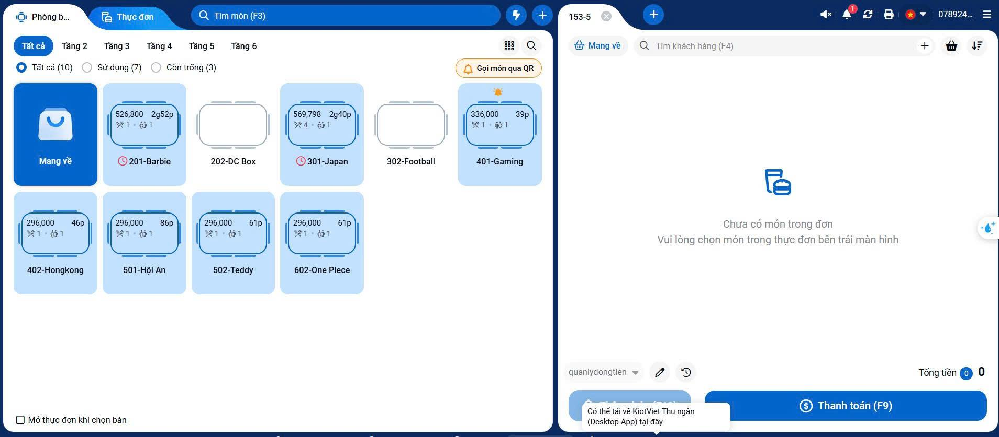
Figure 1. Room and Order Management Interface in KiotViet
Receptionists at GenZ Cinema currently use KiotViet for billing and Excel for advance bookings. Reservations received through channels such as Facebook and Zalo are manually entered into spreadsheets, together with customer information, room or combo selections, and booking times. Because KiotViet mainly reflects rooms with active bills, it does not provide a complete view of future reservations. Receptionists therefore need to check separate Excel files before assigning rooms to walk-in customers, increasing the risk of booking conflicts. Shared staff accounts also reduce accountability because it is difficult to determine who performed billing adjustments, discounts, or other changes.
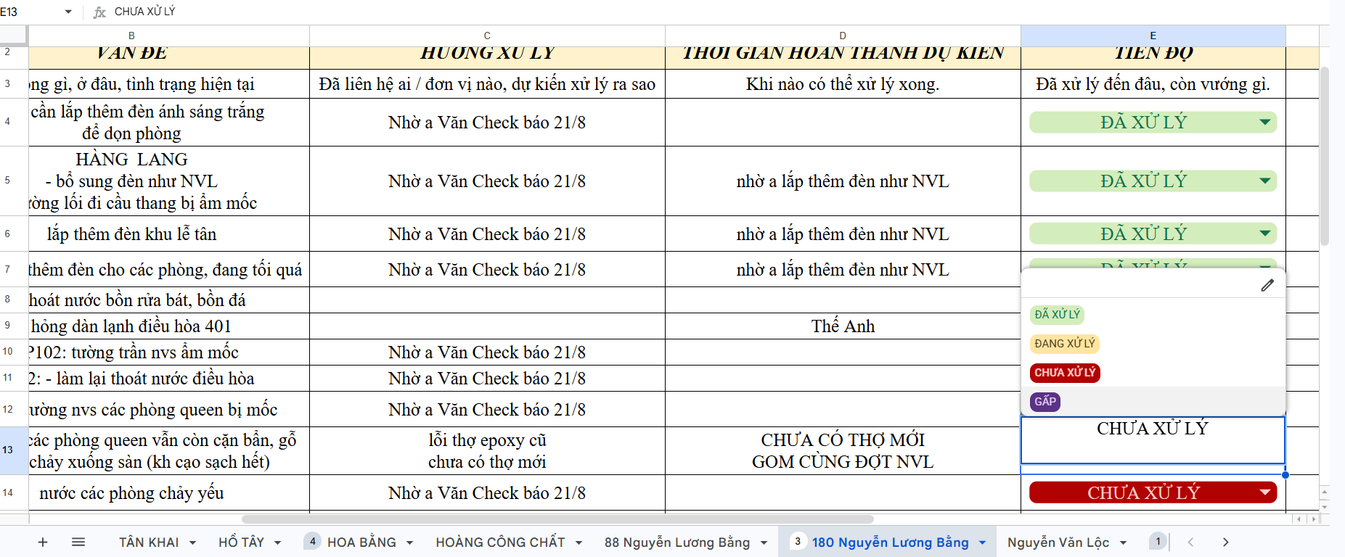
Figure 2. Equipment and Facility Maintenance Tracking in Google Sheets
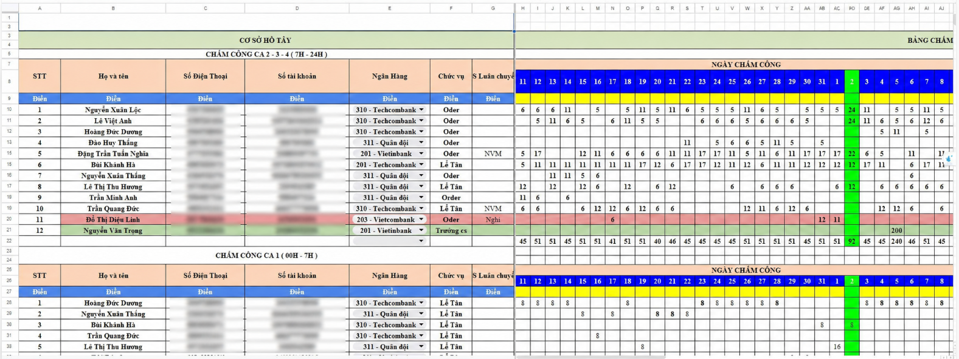
Figure 3. Staff Attendance Records in Google Sheets
Branch Managers manually manage staff attendance and equipment-related records using Excel. Attendance and actual working hours are recorded manually, while equipment incidents and repair records are maintained in separate files with inconsistent formats and supporting evidence. This makes it difficult to track attendance, repair history, related expenses, and equipment condition consistently at each branch.
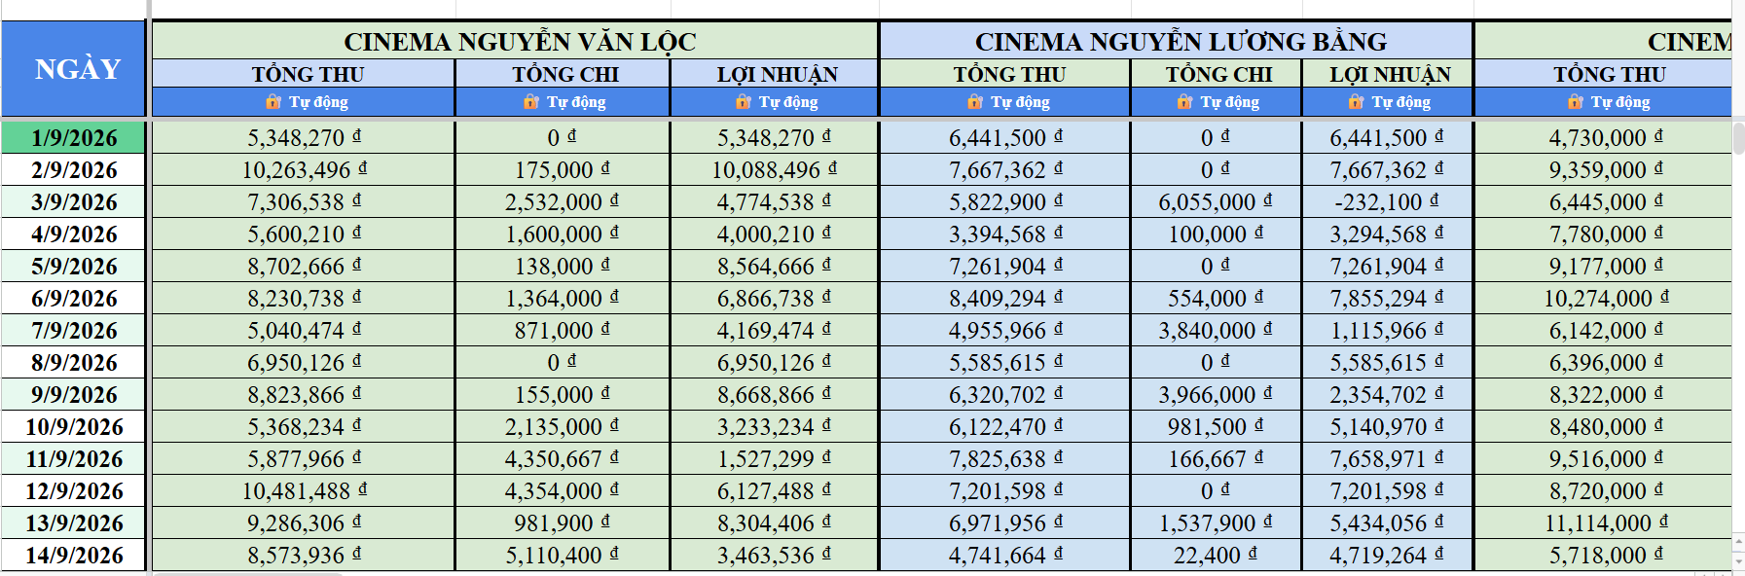
Figure 4. Branch Income and Expense Summary in Google Sheets
The Accountant also relies on multiple sources for daily and monthly financial work. Daily reconciliation requires manually comparing bank-transfer records, cash counts, and sales data from KiotViet. Cash differences require additional checking and explanation, increasing reconciliation effort and the risk of unresolved discrepancies. At the end of each payroll period, attendance records from multiple branches must also be consolidated to calculate hourly salaries, additions, deductions, and salary advances.

The Head Office Manager lacks a centralized view of operations and financial performance across the chain. Although KiotViet provides basic sales information, advance bookings, room utilization, branch expenses, attendance, payroll, and other operational records are distributed across separate spreadsheets and systems. Management therefore needs to consolidate data manually before obtaining an overall view of branch performance.
These disconnected tools and manual processes increase the risk of booking conflicts, inconsistent records, limited transaction traceability, and time-consuming reconciliation. As GenZ Cinema & Music Box expands, relying on separate spreadsheets and third-party tools becomes increasingly difficult to manage. A centralized system is therefore needed to standardize workflows, improve accountability and data consistency, and provide a unified source of operational and financial information across the chain.

III. Existing Solutions

1. KiotViet
KiotViet is a cloud-based POS platform developed by Citigo. At GenZ Cinema, staff currently use the deployed configuration to assign rooms to guests, add food and beverage items to room orders, issue bills at checkout, and review revenue by branch and time period. The KiotViet interface also displays a QR ordering option. Whether guests currently use this feature should be confirmed before describing it as part of the active operating workflow.
Website / Link | https://genzcinema1.kiotviet.vn/
Target Users | Front-desk staff assign rooms, add items, and issue bills; customers order by scanning a QR code in their room; authorized staff review revenue.
Core Features | Assign rooms to guests and view room status; add food and beverage items to orders; allow customers to order through an in-room QR code; issue bills; review revenue.
Strengths | Reliable offline checkout mode; familiar and easy-to-use interface for front-desk staff.
Weaknesses | According to the current workflow, bookings received through Facebook or Zalo and advance reservation details are still recorded in separate spreadsheets. Staff must check those records against room status in KiotViet when assigning rooms.
GAP-01 | Advance bookings and room availability are managed separately, requiring manual cross-checks and creating a risk of conflicting room assignments.
GAP-02 | Shift scheduling, attendance, and payroll require manual coordination and consolidation.
GAP-03 | Shared accounts and fragmented records make it difficult to trace important actions and produce a consistent chain-wide view.

2. Google Sheets
Google Sheets are general-purpose spreadsheet applications used by GenZ Cinema as an ad-hoc operational workaround. Front-desk staff and branch managers rely on them daily to record advance reservations, track staff shift attendance, log equipment repairs. Accountant uses them to manage cash flow manually
Website / Link | N/A
Target Users | Organizations and teams of any size seeking a flexible, zero-marginal-cost data storage and calculation tool.
Core Features | Free-form tabular data entry, formula calculations, shared multi-user editing, filtering, and custom report formatting.
Strengths | Extreme flexibility with zero additional licensing cost; requires virtually no employee training; easily accommodates unstructured notes and manual overrides.
Weaknesses | No automated validation or business logic enforcement; lacks role-based access control and audit trails (any employee can accidentally overwrite or delete records without attribution); zero real-time synchronization with front-desk POS billing; inconsistent sheet layouts across different branches.
GAP-04 | Deposit status, cancellation eligibility, refunds, and no-show handling involve separate records and handoffs.
GAP-05 | Shift scheduling, attendance, and payroll require manual coordination and consolidation.

3. Other existing solutions in the market
MISA eShop and Sapo FnB are considered as market alternatives for selected operational requirements of GenZ Cinema & Music Box. These products are evaluated as potential alternatives and are not part of GenZ’s current operating setup. The comparison examines their documented capabilities and the business scenarios that require further assessment.
1.MISA eShop
Evaluation Area | Description
Target Users | Retail businesses operating individual stores or store chains.
Core Features | Sales management, product and inventory management, inter-store stock transfers, staff permissions, chain-level reporting, and connections with MISA accounting and electronic invoicing products.
Strengths | Provides centralized administration of retail data across stores and supports coordination between sales, inventory, and accounting activities.
Relevance to GenZ | Provides a comparison point for F&B inventory, branch-level sales reporting, and accounting data exchange.
Fit Assessment | Its retail-oriented workflows require further evaluation against GenZ’s hourly room bookings, room changes, usage extensions, and booking-linked deposit policies. These scenarios have not been validated for the proposed deployment.

2.Sapo FnB
Evaluation Area | Description
Target Users | Restaurant and food-service operators managing customer reservations and on-site service.
Core Features | Reservation records containing scheduled arrival times, customer contact details, party sizes, assigned tables or areas, deposit amounts, and reservation statuses.
Strengths | Keeps reservation details, assigned locations, and recorded deposits together, supporting staff when preparing for customer arrivals.
Relevance to GenZ | Provides a comparison point for advance reservations, location assignment, and deposit recording within a service operation.
Fit Assessment | Table-reservation functionality does not by itself establish suitability for hourly room rental. Assessment must cover overlapping room-use intervals, room changes, extensions, time-based charges, and the handling of deposits after cancellations or no-shows.

4. Section Summary
Solution | Supported Features | Strengths | Limitations for GenZ Cinema & Music Box
KiotViet | The current interface provides Overview, Menu, Inventory, Rooms/Tables, Orders, Customers, Cashbook, Reports. The dashboard displays revenue and branch selection. | Supports several day-to-day branch operations on one platform. Staff already use it to manage room activity and sales transactions. | Advance reservations received through social channels are recorded separately. Staff attendance, equipment maintenance, and parts of financial reconciliation also require external records or manual consolidation. The current setup does not provide a single workflow connecting these processes.
Google Sheets | Supports tabular data entry, formulas, shared editing, file permissions, and version history. | Flexible and quick to configure for advance bookings, attendance, maintenance logs, and manual financial tracking. It can accommodate operational requirements that are not handled by the current KiotViet setup. | Business rules depend on users maintaining the sheets correctly. Data is not automatically connected to KiotViet transactions, room status, or payment records. Separate spreadsheets across branches increase the effort required to validate and consolidate information.
MISA eShop | Supports sales, inventory, store and chain management, business reporting, and integration with MISA accounting software. | Centralizes sales and inventory data across stores; supports consolidated reporting and data exchange with accounting software. | Primarily designed for retail operations. Its suitability for GenZ’s specific workflows, including hourly room reservations, room changes or extensions, and booking-linked deposit management, has not been established.

Assessment Area | Conclusion
Gaps in the Current Solutions | KiotViet handles room/table operations, billing, and sales revenue. Google Sheets maintains advance reservations, attendance, maintenance records, operating funds, income and expenses, and financial summaries. Data is not automatically linked between the two tools, requiring staff to manually check room schedules, reconcile transactions, and consolidate figures. This increases the risk of booking conflicts, inconsistent records, and delays in providing management information.
Rationale for Combining KiotViet and Google Sheets | KiotViet supports front-desk sales and billing. Google Sheets complements these functions by handling advance reservations, attendance, maintenance, and financial management, including operating funds, income and expenses, and cash flow summaries. The two tools support different operational needs but do not form a unified management workflow.
Feasibility of Using KiotViet Alone | Using KiotViet alone requires coverage of the workflows currently handled through Google Sheets, particularly advance reservations, fund management, income and expenses, attendance, and maintenance. The current implementation does not replace these spreadsheets. Any extension of KiotViet must be assessed for functional coverage, customization, integration, and total implementation cost.
Cost Implications of Expansion | As GenZ expands its branch network and management requirements, commercial solutions such as KiotViet or MISA may require subscription upgrades, additional modules, or separate software subscriptions. Recurring fees and integration costs may increase the total long-term expenditure. GCMS development is therefore prioritized to consolidate essential workflows on one platform, enable greater control over future functionality, and reduce reliance on purchasing multiple separate services. Its cost effectiveness must also account for development, operation, and maintenance expenses.
Direction of the Proposed GCMS Solution | Develop a centralized system connecting reservations, deposits, billing, payments, attendance, payroll, maintenance, operating funds, and income and expenses. The system will standardize workflows, provide role- and branch-based access, maintain action histories, and deliver consistent chain-wide reporting, reducing duplicate data entry and manual reconciliation.

IV. Proposed Solution
GCMS is a centralized, role-based web application designed to support the operational model of the GenZ Cinema & Music Box chain. It addresses the fragmentation identified in the current process, where KiotViet is mainly used for front-desk billing while spreadsheets are used for advance bookings, attendance, maintenance, and financial tracking. GCMS replaces this fragmented operational approach with a unified platform for booking and room management, F&B and billing, deposits and payments, inventory, workforce management, payroll, equipment maintenance, expenses, cashflow reconciliation, and management reporting. External services such as SePay, cloud storage, and email are integrated where required.
Each user role is provided with functions aligned with its business responsibilities. Receptionists can manage walk-in and advance bookings, room availability, check-in/check-out, F&B orders, deposits, and customer payments, while GCMS validates booking conflicts and maintains transaction history. Branch Managers manage rooms, shift availability, attendance, inventory, equipment incidents, branch expenses, operating funds, and daily cash closing. The Accountant manages incoming funds, deposit refunds, expense approval and reimbursement, financial reconciliation, payroll, and financial-period closing. The Head Office Manager manages branches, centralized pricing and access configuration, major approvals, and chain-level operational and financial reports.
GCMS is proposed because the combination of tools currently used by GenZ does not provide an integrated workflow for its time-based room rental and multi-branch management processes. By centralizing operational and financial data, enforcing defined business rules, and maintaining role-based access and auditability, GCMS is intended to reduce manual reconciliation, improve data consistency and accountability, and provide management with a more consistent view of operations across the chain.

V. Project Scope & Limitations

1. Major Features (giống level F1 của feature tree, <10 major feature)(chapter 5 giáo trình swr)
ID | Feature Name | Description | Addressed Gaps
FE-01 | System Administration and Configuration | GCMS manages user accounts, role-based access, password recovery, and audit logs for the four business roles: Head Office Manager, Branch Manager, Receptionist, and Accountant. It also supports branch setup, room categories, time-based pricing, combo packages, and room records, with administrative actions restricted according to each role’s authority. | GAP-03
FE-02 | Booking and Room Operations | GCMS records walk-in and advance bookings entered by Receptionists, and supports booking updates, cancellation, check-in, room changes, stay extensions, and no-show handling. It tracks room status, records booking deposits and eligible refunds, and generates checkout bills that account for room charges, overtime, food and beverage, service charges, deposits, and manually entered discounts. Payments can be recorded as cash or confirmed QR payments. | GAP-01,GAP-04
FE-03 | F&B, Inventory and Equipment Management | GCMS manages the menu and links food and beverage orders to an active room booking. It tracks inventory levels and stock movements, including receipts, sales deductions, and reason-recorded adjustments. The system also records equipment assets and incidents, supports repair planning and outcome tracking, and manages purchase or replacement proposals and approvals. | GAP-03
FE-04 | Workforce and Payroll Management | GCMS manages employee assignment to a home branch, employee access deactivation, shift availability, shift schedules, and monthly attendance records. Branch Managers configure shifts, record attendance, and close attendance periods; Receptionists can view their schedules and report attendance errors before closure. Accountants generate payroll from locked attendance records, manage salary advances and adjustments, review payroll, export payroll data to Excel, and record salary payments. | GAP-02, GAP-05
FE-05 | Financial Management and Reporting | GCMS supports branch cash closing using system-recorded revenue and actual cash counts, records cash variances and explanations, and provides reconciliation records and variance alerts for review. It manages branch operating-fund requests and allocation, incoming-fund records, expense vouchers, approvals, reimbursements, and financial-period closing. Head Office Managers, Branch Managers, and Accountants can access dashboards and reports according to their roles; financial data can also be exported for tax-accounting purposes. | GAP-03

2. Limitations & Exclusions
ID | Excluded Item | Reason
LI-01 | Customer-facing booking portal (web or mobile app) | Bookings from social media channels are received by staff and entered manually into the system. A self-service portal for customers requires additional frontend development, payment gateway integration, and real-time availability exposure that exceeds the current project timeline. Deferred to v2.
LI-02 | Hardware barcode scanner for stock receiving | Barcode-based stock intake requires device driver integration and physical hardware provisioning across 20 branches. v1 supports manual quantity entry for stock receiving. Hardware integration is deferred to v2 pending standardization of devices across branches.
LI-03 | Tax report generation | Tax reporting format depends on the company's legal entity type and applicable tax regulations, which vary and are subject to change. v1 provides raw financial data export sufficient for an external accountant to prepare tax filings.
LI-04 | Content licensing and copyright compliance | GCMS does not track, validate, or enforce compliance with film streaming licenses (e.g., Netflix content rights), music performance rights (e.g., VCPMC), or any intellectual property agreements applicable to Cinema Room or Music Box operations. These obligations are managed entirely outside the system.
LI-05 | Regulatory and safety compliance enforcement | GCMS does not monitor or enforce compliance with fire safety regulations (PCCC), government permits for entertainment venues operating after 23:00, or any other statutory licensing conditions. Compliance with applicable laws remains the operational responsibility of each branch.
LI-06 | Recipe / BOM-based Ingredient Management | GCMS does not maintain recipes or Bills of Materials for prepared F&B items and does not automatically deduct ingredient quantities based on recipes. Packaged items may be deducted automatically on sale, while prepared-item ingredients are adjusted manually by the Branch Manager.

Definition and Acronyms
Acronym | Definition
GCMS | GenZ Cinema & Music Box Management System
F&B | Food and Beverage
POS | Point of Sale — a system used to process customer transactions at the point of purchase
PCCC | Phòng cháy chữa cháy
VCPMC | Vietnam Center for Protection of Music Copyright
GAP | Gap — label used to identify gaps between current and required capabilities
FE | Feature — prefix used for feature identifiers
LI | Limitation — prefix used for limitation and exclusion identifiers
QR | Quick Response
BOM | Bill of Materials

